**SUHASITA RANI(231701013)ASSIGNMENT-02**

**AIM: REMOTE APP**

**PROCEDURE:**

1. Open Figma and create a new file

2. Set up frames of different screen sizes

3. Gather Resources

4. Start with outline to a low defined basic structure

5. Include all essential components like home menu, search bar etc

6. Refine the design ensuring all the elements are pixel perfect

7. Create your own remote app

8. Export the design assets for development

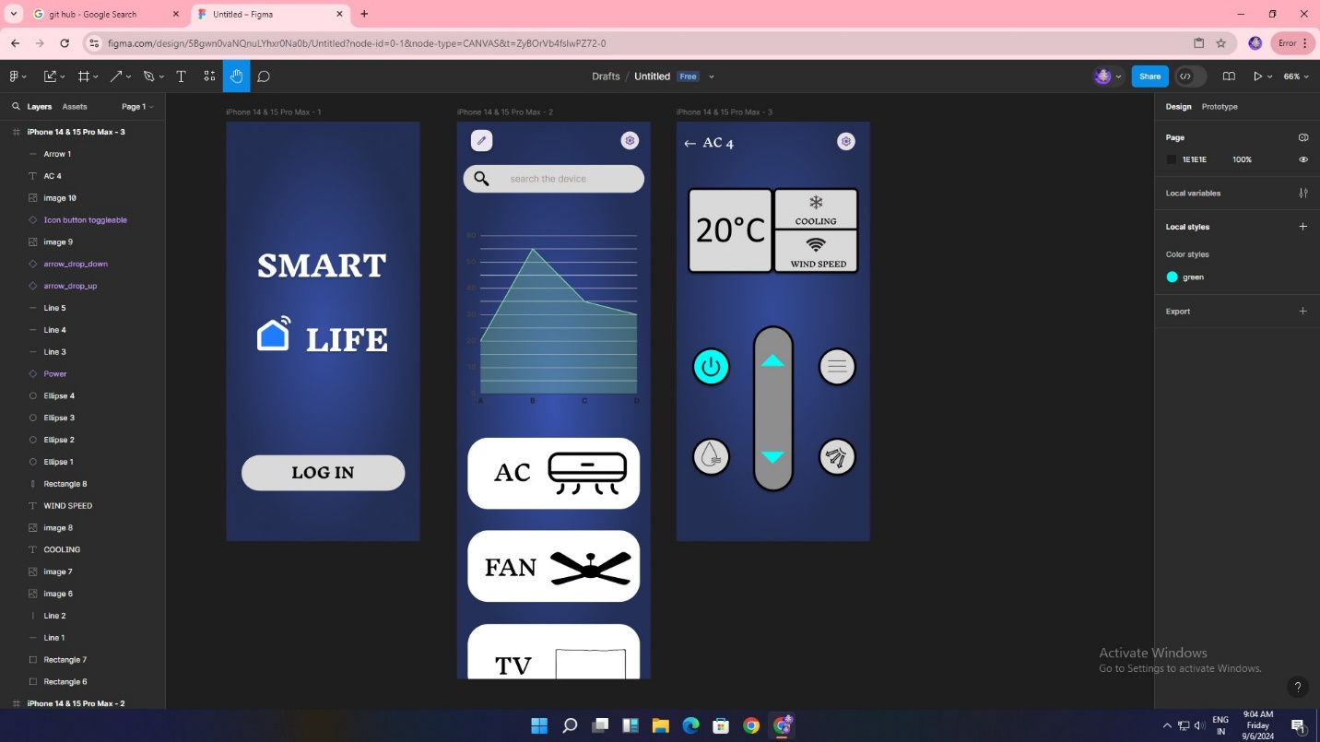

**RESULT :**

The experiment is done and the output is verified